# Barplot: Retinoblastoma diagnosis over the years

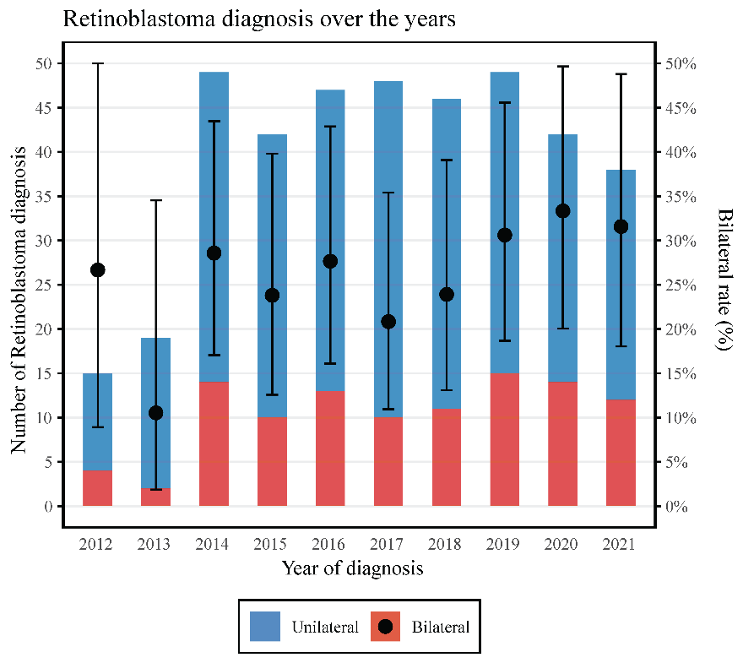

Figure 1: Evolution of the total amount of diagnosis of retinoblastoma over the years 2012 – 2021 (left axis), grouped by unilateral (blue) and bilateral (red) tumors. The rate of bilateral tumors and their 95% confidence interval is represented by the black dot and the error bar (right axis).